Assignment 1

2025/7/16

This is the report for the assignment 1:

Code used in the summary table:

mean_val <- mean(dataset$V1)

median_val <- median(dataset$V1)

sd_val <- sd(dataset$V1)

quantiles <- quantile(dataset$V1)

min_val <- min(dataset$V1)

max_val <- max(dataset$V1)

***The Summary Table:***

| **Statistic** | **Value** |
| --- | --- |
| Mean | 5.32 |
| Median | 5.00 |
| Standard Deviation | 2.32 |
| 1st Quartile (Q1) | 4.00 |
| 3rd Quartile (Q3) | 6.00 |
| Minimum | 2.00 |
| Maximum | 15.00 |

I personally think that the Mean is the best way to describe the entire dataset, since it is reflecting the average the duration of hospital stays of patients admitted to the hospital with COVID-19.

1. Histogram:

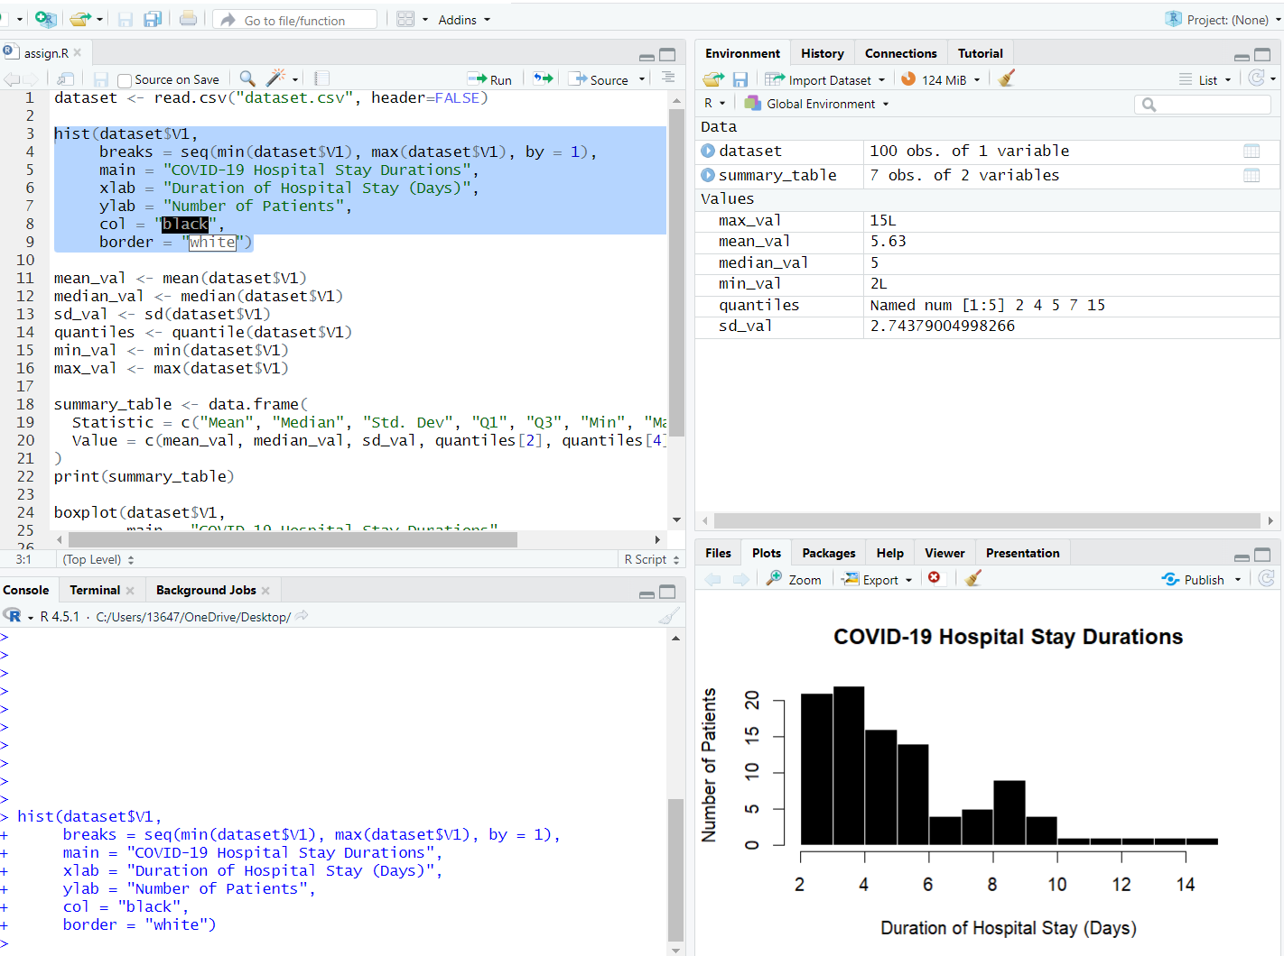

This distribution implies that the majority of COVID-19 patients had relatively short hospital stays, but a small subset required extended care.

1. Boxplot图形用户界面, 应用程序

   AI 生成的内容可能不正确。